Project: Forecasting the Energy Consumption of Households in the United Kingdom
General Context: You will work on the dataset " Households in the United Kingdom ". Your mission is to develop models capable of forecasting the electricity consumption of different types of households (ACORN segments). This project will lead you to explore the data, understand consumption behaviours, model the impact of weather, and finally build and evaluate short- and medium-term forecasting models.

Objectives and Project Workflow (by group): Each group will focus on three ACORN segments (which will be assigned to you, available in the data/02_processed folder). For this/these segment(s):
- Phase 1: Analysis and Characterization
  - Analyze in an exploratory manner typical electricity consumption profiles (daily, weekly, seasonal if possible).
  - Quantify the influence of weather conditions (especially temperature) on consumption.
  - Identify the key temporal dynamics (autocorrelation, seasonalities). This phase is crucial for properly understanding the data before modeling.
- Phase 2: Short-Term Forecasting (48h horizon - 30-minute step)
  - Develop a model to forecast electricity consumption at a 30-minute step for the next 48 hours: for the period from January 13, 2014 at 00:00 to January 14, 2014 at 23:30.
  - Use historical data prior to this period for training and validating your model.
  - Rigorously evaluate your model's performance.
- Phase 3: Medium-Term Forecasting (1-month horizon - daily step)
  - Develop a model to forecast aggregated daily electricity consumption for a full month: from January 13 to February 13, 2014).
  - Use historical data prior to this month for training and validation.
  - Rigorously evaluate your model's performance.
- (Bonus) Phase 4: Interactive Presentation
  - Present your analyses, models, and forecasting results interactively using a dashboard developed with Streamlit or Dash (Streamlit is easier for beginners to get started with).
Data Provided:
- Electricity consumption data (preprocessed as average profiles by ACORN segment). The historical period for training will be specified (e.g.: data from 2012-2013).
- Historical weather data (temperature, humidity, wind speed, etc.) synchronized with the consumption data.
- Public holiday data
- For the forecasting periods (13-14 January 2014 and from 13/01/2014 to 13/02/2014), you will use the real weather data for these periods as if they were perfect forecasts.

Main Evaluation Criteria:
- Quality of the Exploratory Analysis (Phase 1): Depth of data understanding, relevance of visualizations and interpretations.
- Rigor of the Modeling Approach (Phases 2 & 3): Justified model choices, correct validation strategy, relevant feature engineering.
- Forecasting Performance: Quality of forecasts measured using appropriate metrics (RMSE).
- Clarity and Relevance of the Presentation: Quality of the oral presentation, clarity of explanations, and (for the bonus) quality, interactivity, and usefulness of the Dash/Streamlit dashboard.
- Teamwork and Project Management: Ability to collaborate effectively and deliver a complete project on time.
A few tips:
- Start simple: Always implement a simple reference model (baseline) so you can judge the added value of more complex models.
- Iterate: Do not seek perfection on the first try. Build a first version of your models, evaluate it, then improve it.
- Communicate: Communicate regularly within your group, share tasks and do not hesitate to ask the instructors for help.
- Be critical: Take a critical look at your own results. A model is never perfect.
- Suggested project tree:
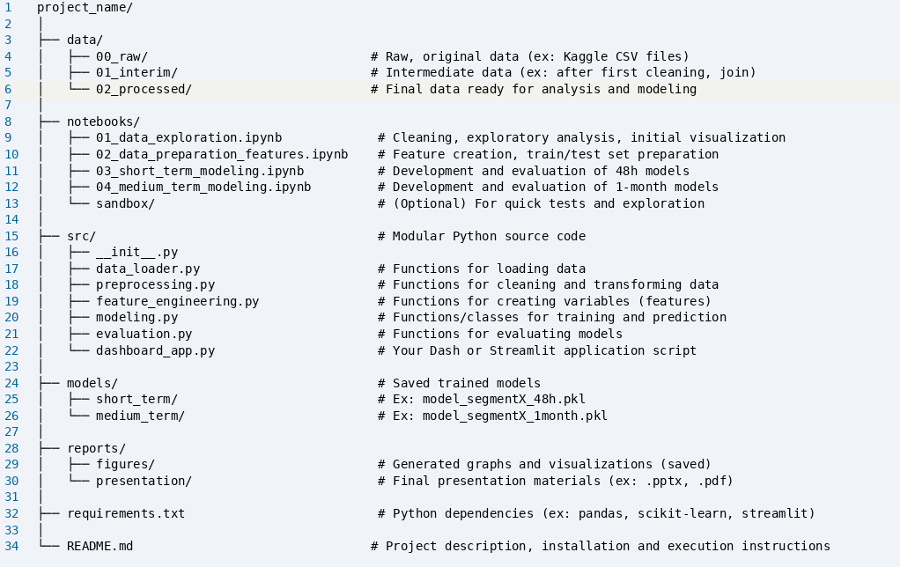

Good luck with the project, everyone!

Two versions of the files are available in csv and parquet. Prefer using the "parquet" format because it preserves the data types

